# Measure Distance and Velocity with a Rotary Encoder

A rotary encoder measures the rotation of a shaft or other rotating object. As the encoder rotates it sends pulses that can be counted to track shaft angle or calculate rotational speed. Most encoders can also indicate rotational direction.

The resolution of an encoder is measured in pulses per revolution. There are many different resolutions available. Some encoders pulse 360 times per revolution, measuring to 1 degree of accuracy. Some other common resolutions are 512, 1024, 2048 or 4096.

## Measuring Distance

For this lab, there is a motor with gearbox and integrated encoder. The output shaft of the gearbox has a 4” wheel. By calculating the circumference of the wheel, and the number of encoder counts per wheel revolution, it is easy to measure travel distance from encoder counts.

1. **Determine distance traveled per wheel rotation**. Calculate the circumference of the wheel (diameter x Pi). This is a 4” wheel. Wheel Circumference = ________ (inches/rev)
2. **Determine the counts per revolution.** Power the wheel and note how many pulses are counted in a single rotation (this first column of output on the Serial Monitor is the count). If you want higher accuracy, have the wheel do 10 full rotations and divide your count by 10. Encoder Resolution = ________ (counts/rev)
3. **Calculate the number of encoder counts per inch.** Divide the encoder resolution by the wheel circumference to derive a conversion factor. Conversion Factor = ________ (counts/inch)
4. **Enter your calibration factor.** Type your conversion factor into the Serial monitor and press Enter. Make sure the Newline option is selected, as shown in the figure on the next page.

Now when you run the motor, the second column of output on the Serial Monitor will show how many inches the wheel has travelled.

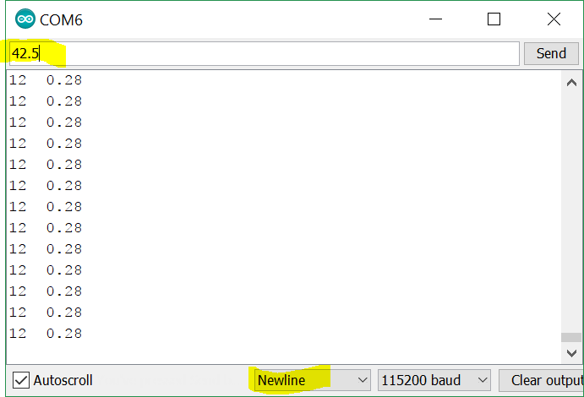

## Calculating Velocity

With an accurate way to measure distance, it becomes an easy take to compute velocity. Velocity is the change in distance divided by the time it took to move that distance.

|  |  |
| --- | --- |
| Velocity = | Change in distance (inches) |
| Change in time (seconds) |

Given that the output in the Serial Monitor is updated 10 times per second, calculate the velocity on the wheel in inches per second. Velocity = _________ (inches/sec)

Hint: You can pause the output of the serial monitor by unchecking the Autoscroll option at the bottom of the window.

Consider taking distance measures that are separated by 10 readings, which will be a full second of time, for more accuracy.

What happens to the velocity if the motor runs in the opposite direction?

It is often the case the robot speed is measured in feet/sec rather than inches/sec. How fast would this robot be travelling. Velocity = ________ (ft/sec)

## Extra Credit

What conversion factor could you apply to measure the degrees of rotation? Type your answer into the Serial Monitor and see if it works.